Requirement Analysis

🌟 Definition
# Source: AI Source: Provided by: [Data Path: Persons Table -> ID Column: 1, Name_En Column: Motasem Essam] -> From: [ChatGPT] on [6/7/2026]
Requirement Analysis is the second phase of the Software Development Life Cycle (SDLC) where the development team gathers, analyzes, documents, and validates what the software system must do.
The main question in this phase is:
"What does the user need from the software?"

🎯 Purpose of Requirement Analysis
# Source: AI Source: Provided by: [Data Path: Persons Table -> ID Column: 1, Name_En Column: Motasem Essam] -> From: [ChatGPT] on [6/7/2026]
The goal of this phase is to:
- Understand user needs
- Define system functionality
- Identify business requirements
- Remove unclear requirements
- Create a clear foundation for design and development

🔄 Requirement Analysis Process
# Source: AI Source: Provided by: [Data Path: Persons Table -> ID Column: 1, Name_En Column: Motasem Essam] -> From: [ChatGPT] on [6/7/2026]
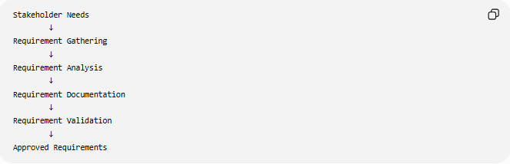
Stakeholder Needs
↓
Requirement Gathering
↓
Requirement Analysis
↓
Requirement Documentation
↓
Requirement Validation
↓
Approved Requirements

🧩 Main Activities in Requirement Analysis

1️⃣ Requirement Gathering (Elicitation)
# Source: AI Source: Provided by: [Data Path: Persons Table -> ID Column: 1, Name_En Column: Motasem Essam] -> From: [ChatGPT] on [6/7/2026]
Definition
The process of collecting information from stakeholders about what the system should do.

Sources of Requirements
- Customers
- End users
- Business owners
- Managers
- Existing systems
- Documents
- Regulations

Techniques Used
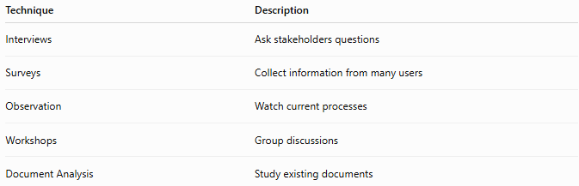
Technique | Description
Interviews | Ask stakeholders questions
Surveys | Collect information from many users
Observation | Watch current processes
Workshops | Group discussions
Document Analysis | Study existing documents

Example
For an online shopping system:
Stakeholder says:
"Customers should be able to search products."
Requirement:
The system shall allow customers to search products by name.

2️⃣ Requirement Analysis
# Source: AI Source: Provided by: [Data Path: Persons Table -> ID Column: 1, Name_En Column: Motasem Essam] -> From: [ChatGPT] on [6/7/2026]
Definition
The collected requirements are examined to understand:
- What is needed?
- Is it possible?
- Are there conflicts?
- Are requirements complete?

Example
Initial request:
"The system should be fast."
Analysis changes it into:
"The system should load pages within 2 seconds."
A vague requirement becomes measurable.

3️⃣ Requirement Classification
# Source: AI Source: Provided by: [Data Path: Persons Table -> ID Column: 1, Name_En Column: Motasem Essam] -> From: [ChatGPT] on [6/7/2026]
Requirements are divided into categories.

A) Functional Requirements
Definition
Describe what the system should do.
Examples:
- User can register
- User can log in
- Customer can place orders
- Admin can manage products

Example:
The system shall allow users to reset passwords.

B) Non-Functional Requirements
Definition
Describe how the system should perform.
Examples:
- Performance
- Security
- Reliability
- Usability
- Scalability

Example:
The system shall support 10,000 users simultaneously.

Functional vs Non-Functional
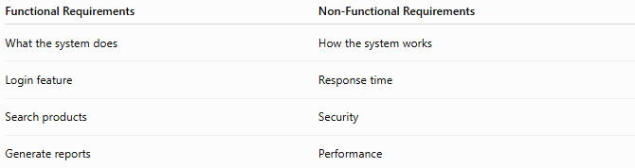
Functional Requirements | Non-Functional Requirements
What the system does | How the system works
Login feature | Response time
Search products | Security
Generate reports | Performance

4️⃣ Requirement Documentation
# Source: AI Source: Provided by: [Data Path: Persons Table -> ID Column: 1, Name_En Column: Motasem Essam] -> From: [ChatGPT] on [6/7/2026]
Definition
Writing requirements in a formal document.
The main document is:
📄 SRS (Software Requirements Specification)

SRS Contains:
1. Introduction
- Project overview
- Purpose
- Scope

2. Functional Requirements
Example:
FR-01:
User can create an account.

3. Non-Functional Requirements
Example:
NFR-01:
System response time should be less than 3 seconds.

4. User Requirements
Describes user expectations.

5. System Requirements
Technical details needed by developers.

5️⃣ Requirement Validation
# Source: AI Source: Provided by: [Data Path: Persons Table -> ID Column: 1, Name_En Column: Motasem Essam] -> From: [ChatGPT] on [6/7/2026]
Definition
Checking that requirements are correct and acceptable.

Validation Questions:
✅ Are requirements complete?
✅ Are they clear?
✅ Are they realistic?
✅ Are they consistent?
✅ Do stakeholders agree?

6️⃣ Requirement Prioritization
# Source: AI Source: Provided by: [Data Path: Persons Table -> ID Column: 1, Name_En Column: Motasem Essam] -> From: [ChatGPT] on [6/7/2026]
Definition
Ranking requirements based on importance.

Example:
High Priority
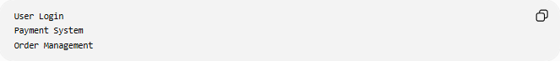
User Login
Payment System
Order Management
Low Priority
Theme Customization
Extra Reports

Common Method:
MoSCoW Prioritization
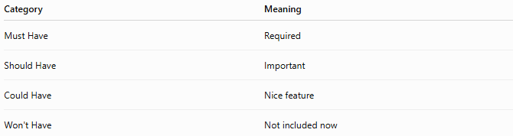
Category | Meaning
Must Have | Required
Should Have | Important
Could Have | Nice feature
Won't Have | Not included now

📚 Requirement Analysis Documents
# Source: AI Source: Provided by: [Data Path: Persons Table -> ID Column: 1, Name_En Column: Motasem Essam] -> From: [ChatGPT] on [6/7/2026]
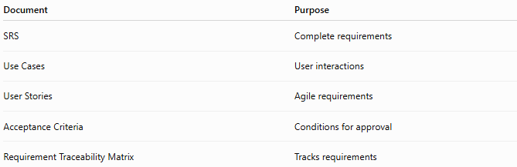
Document | Purpose
SRS | Complete requirements
Use Cases | User interactions
User Stories | Agile requirements
Acceptance Criteria | Conditions for approval
Requirement Traceability Matrix | Tracks requirements

📝 Example: ATM System Requirements
# Source: AI Source: Provided by: [Data Path: Persons Table -> ID Column: 1, Name_En Column: Motasem Essam] -> From: [ChatGPT] on [6/7/2026]
Functional Requirements
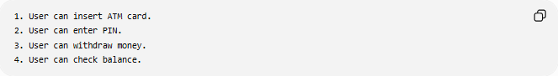
1. User can insert ATM card.
2. User can enter PIN.
3. User can withdraw money.
4. User can check balance.

Non-Functional Requirements
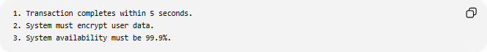
1. Transaction completes within 5 seconds.
2. System must encrypt user data.
3. System availability must be 99.9%.

🛠️ Tools Used in Requirement Analysis
# Source: AI Source: Provided by: [Data Path: Persons Table -> ID Column: 1, Name_En Column: Motasem Essam] -> From: [ChatGPT] on [6/7/2026]
Examples:
- Jira — Track requirements and tasks
- Confluence — Document requirements
- Microsoft Visio — Create diagrams

📊 Output of Requirement Analysis
# Source: AI Source: Provided by: [Data Path: Persons Table -> ID Column: 1, Name_En Column: Motasem Essam] -> From: [ChatGPT] on [6/7/2026]
At the end of this phase:
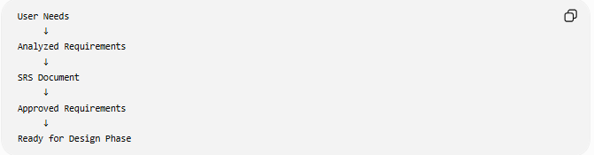
User Needs
↓
Analyzed Requirements
↓
SRS Document
↓
Approved Requirements
↓
Ready for Design Phase

🧠 Simple Analogy
# Source: AI Source: Provided by: [Data Path: Persons Table -> ID Column: 1, Name_En Column: Motasem Essam] -> From: [ChatGPT] on [6/7/2026]
Building a house:
Requirement Analysis Phase
Before drawing the design:
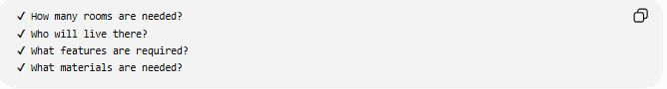
✔ How many rooms are needed?
✔ Who will live there?
✔ What features are required?
✔ What materials are needed?
Software example:
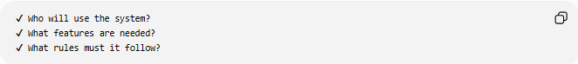
✔ Who will use the system?
✔ What features are needed?
✔ What rules must it follow?

🧭 Summary
# Source: AI Source: Provided by: [Data Path: Persons Table -> ID Column: 1, Name_En Column: Motasem Essam] -> From: [ChatGPT] on [6/7/2026]
The Requirement Analysis Phase is the SDLC stage where developers and stakeholders identify, analyze, document, and validate software requirements. It produces the SRS (Software Requirements Specification) document, which defines functional and non-functional requirements and acts as the foundation for the design, development, and testing phases.

